_{PEEP}

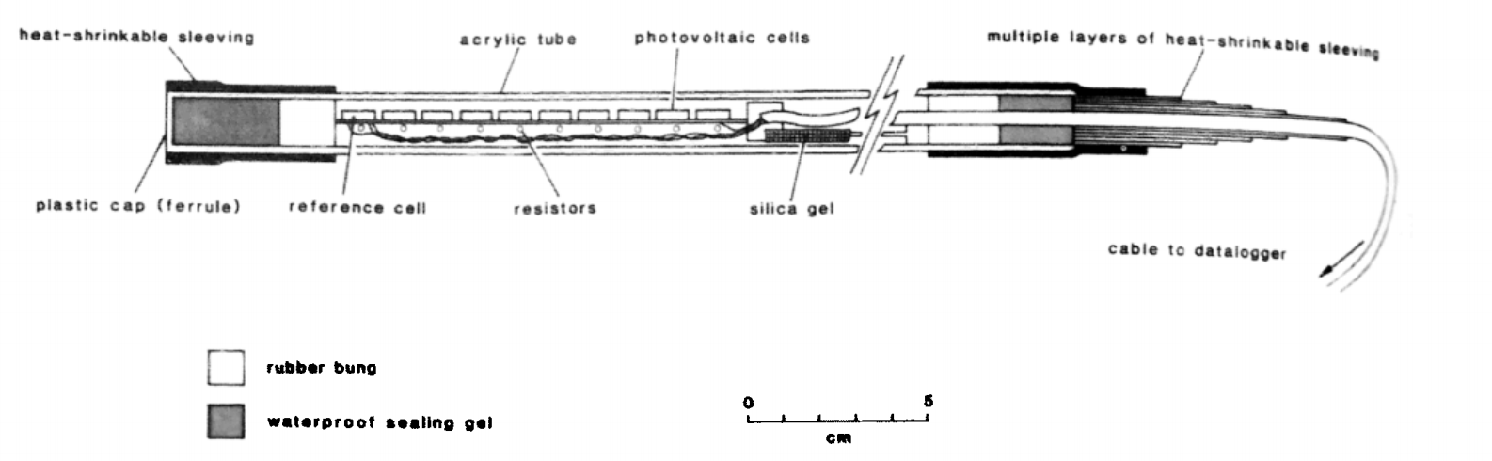

Goal | Morphological measurements
Typical area | River banks, gullies, canals, tidal mudbanks
Typical time resolution | Days–months
Investment costs | < 1750 €
Operation Costs
Labor | low
Spatial Coverage | spot
Time Frequency | continuous
Detail level | High (2 mm vertical resolution)

Method
.
Materials
Photo-Electronic Erosion Pin (PEEP) system
Additional information

