_{SED Sensor}

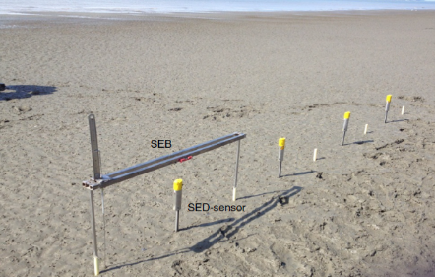

Goal | Morphological measurements
Typical area | Salt marshes, mangroves, tidal flats, dunes, beaches
Typical time resolution | Days–months
Investment costs | < 1000 €
Operation Costs
Labor | low
Spatial Coverage | spot
Time Frequency | continuous
Detail level | High (2 mm vertical resolution)

Method
When in use, a SED-sensor is inserted vertically into the seabed, leaving ca. half of the measuring section above the seabed. During measurement, a current runs through each light sensitive cell, which is proportional to the amount of light on each cell. This current is measured over a resistor to give a voltage output. In this way, above-ground and below-ground cells will give higher and lower output accordingly.

Materials
- Sed Sensor
Additional information

