DGPS-RTK

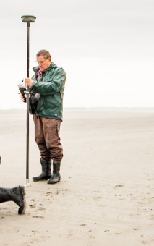

Goal | Morphological measurements
Typical area | Salt marshes, mangroves, tidal flats, dunes, beaches
Typical time resolution | Weeks–decades
Investment costs | < 25,000
Operation Costs
Labor | High
Spatial Coverage | Medium (~ 1 km)
Time Frequency | Interval
Detail level | High 5–25 mm vertical resolution)

Method
The operator walks with the DGPS-RTK in transects line or areas marking the terrain at certain distances. It is important to measure all the important features in terrain (e.g. deeper points or channels). In this way the cross sections or interpolated surfaces are more realistic.
Materials
DGPS-RTK
Additional information

