_{Erosion Pin}
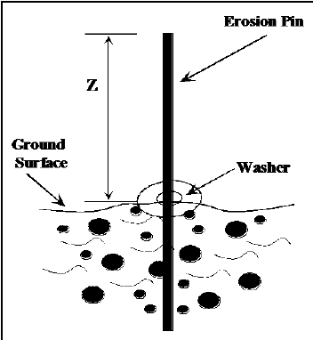

Goal | Morphological measurements
Typical area | Salt marshes, mangroves, tidal flats, dunes, beaches
Typical time resolution | Weeks–months
Investment costs | < €5
Operation Costs
Labor | High
Spatial Coverage | spot
Time Frequency | interval
Detail level | High (~ 10 mm vertical resolution)

Method
Pins are inserted throughout the surveyed cross sections. The steel pins are 0.6 m long with a diameter of 10 mm and were inserted perpendicular to the particular surface (e.g., pins in the bank were horizontal and pins on the top of slump blocks were vertical) so that 0.3 m was exposed. The length of the exposed portion of each pin was measured on a monthly basis.

Materials
- Erosion pins
Additional information

