_{Acoustic sensor}

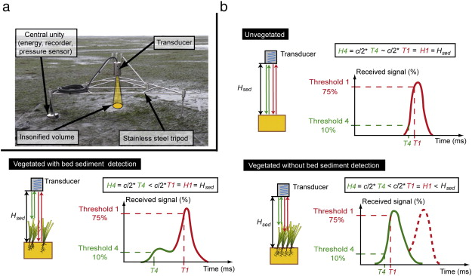
Ganthy, F., Sottolichio, A., Verney, R., 2013. Seasonal modification of tidal flat sediment dynamics by seagrass meadows of Zostera noltii (Bassin d'Arcachon, France). J. Mar. Syst. S233–S240 http://dx.doi.org/10.1016/j.jmarsys.2011.11.027 (XII International Symposium on Oceanography of the Bay of Biscay 109–110, Supplement).

Goal | Morphological measurements
Typical area | Salt marshes, tidal flats, dunes, beaches, subtidal areas
Typical time resolution | Intra-tide–months
Investment costs | < 8000 €
Operation Costs
Labor | medium
Spatial Coverage | spot
Time Frequency | continuous
Detail level | high (1-2 mm vertical resolution)

Method
.
Materials
- Acoustic sensor
Additional information

