_{Electro-resistivity sensor}

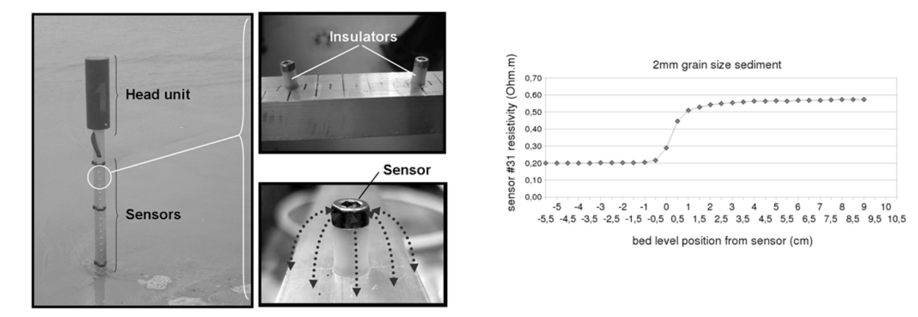
Arnaud, G., Mory,M., Abadie, S., Cassen,M., 2009. Use of a resistive rods network to monitor bathymetric evolution in the surf/swash zone. J. Coast. Res. 1781–1785.

Goal | Morphological measurements
Typical area | Beaches
Typical time resolution | Intra-tide–months
Investment costs | < 6000 €
Operation Costs
Labor | medium
Spatial Coverage | spot
Time Frequency | continuous
Detail level | low (10-30 mm vertical resolution)

Method
.
Materials
- Electro-resistivity sensor
Additional information

