_{Photogrammetry/SFM}
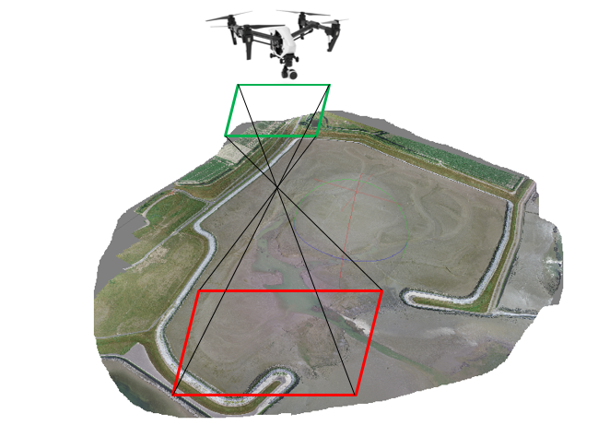
Goal | Morphological measurements
Typical area | Tidal Flats, beaches, dunes
Typical time resolution | Weeks–decades
Investment costs | 3500 €
Operation Costs | 70€ per session ( including 0.21€/km (traveling costs) + researcher hourly rate *3.5 hours)
Labor | medium
Spatial Coverage | medium- large areas (0.1–1 km2)
Time Frequency | Interval (up to 15 per month)
Detail level | Low to medium (1-2 cm vertical resolution)

Method
This method is preferably done during the low tide. The drone is deployed and pictures are taken with an overlap of at least 80% while the drone flies in passages to cover the area. The pictures are later processed using structure for motion techniques and a 3D model is generated from the 2D images.
Materials
- Drone
- SFM software
Additional information
The limitations of this method are similar to the LIDAR. Nevertheless the deployment costs are much lower. The resolution is higher but the spatial coverage is of course lower than the LIDAR.

