Guided Conversation Participant Handbook Template

Administrative
- Information about your organisation / project.

- Consent Checklist – if data is being recorded, a ‘Yes / No’ checklist can help participants agree on how their data will be used and confirm this via their signature.

[Visual prompt / space for notes and drawing 1]

[Radar 1 Title]
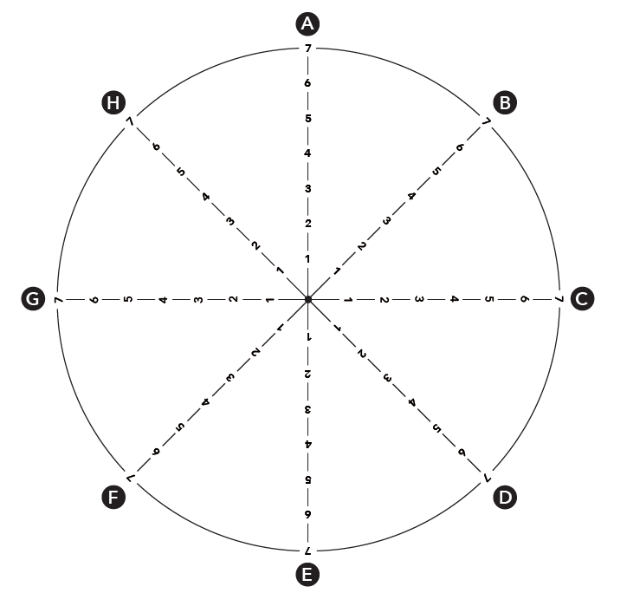

[Topic A]
[Topic B]
[Topic C]
[Topic D]
[Topic E]
[Topic F]
[Topic G]
[Topic H]

[Visual prompt / space for notes and drawing 2]

[Radar 2 Title]
[Topic A]
[Topic B]
[Topic C]
[Topic D]
[Topic E]
[Topic F]
[Topic G]
[Topic H]

[Visual prompt / space for notes and drawing 1]

[Radar 3 Title]
[Topic A]
[Topic B]
[Topic C]
[Topic D]
[Topic E]
[Topic F]
[Topic G]
[Topic H]

Action Plan Notes:
Signpost:

Support:

Referral:

[DELETE THE CONTENT THAT FOLLOWS THIS PAGE IF FOLLOW-ON CONVERSATIONS ARE NOT RELEVANT]

[Radar 1 Title] Update
[Topic A]
[Topic B]
[Topic C]
[Topic D]
[Topic E]
[Topic F]
[Topic G]
[Topic H]

[Radar 2 Title] Update
[Topic A]
[Topic B]
[Topic C]
[Topic D]
[Topic E]
[Topic F]
[Topic G]
[Topic H]

[Radar 3 Title] Update
[Topic A]
[Topic B]
[Topic C]
[Topic D]
[Topic E]
[Topic F]
[Topic G]
[Topic H]

Action Plan Update
Signpost:

Support:

Referral:

